Week 14 Notes

PL/SQL

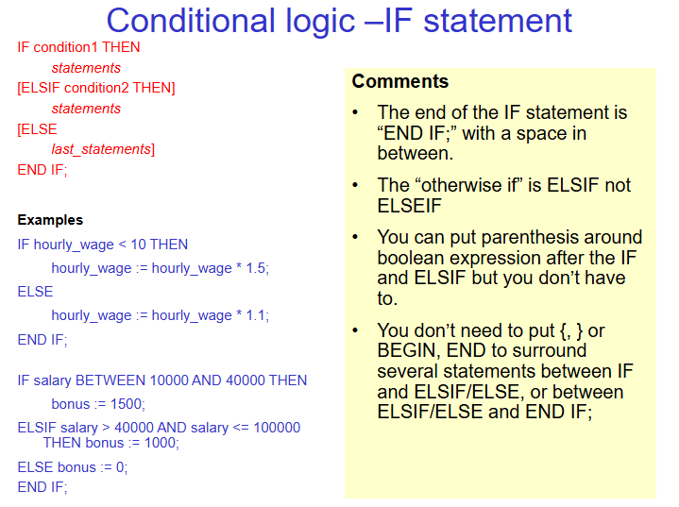

Loops:

There needs to be an exit condition or its infinite

Use for to loop with condition counts 1…5

Or use Reverse to count backwards 5..1

Combining this with Tables:

Making a Curser(pointer)



Runs query and then store in memory as a pointer to first object

This allows for looping through all the salaries with the pointer.

Make sure to add “exit when c1%notfound;”

Functions:

Functions() parameter has a inward parameter

Procedures:

Have 3 kinds of parameters -

IN, OUT, INOUT

Triggers:

:new.salary – hold new value

:old.value – hold old value

Solutions for first order SQL injections:

